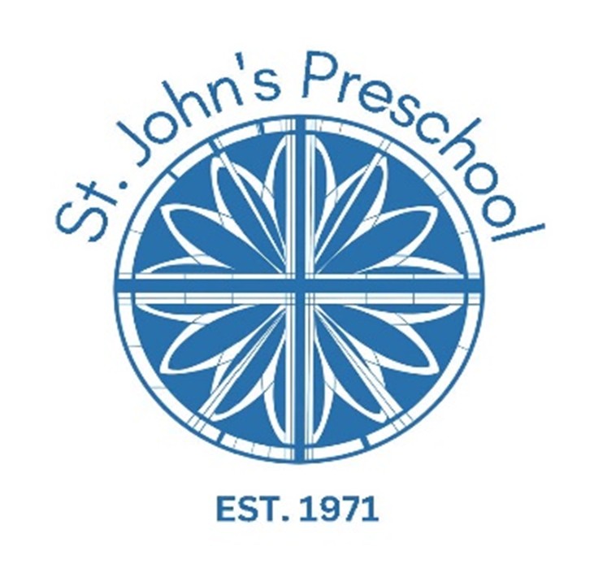

Parent Handbook
2025/2026

St. John’s Episcopal Church
1623 Carmel Road
Charlotte, N.C. 28226
Office - 704-366-3039
Cell - 704-998-7221
Preschool@stje.org

Welcome and School Pledge 1
Mission Statement and Philosophy 2
Tuition 3
Additional Fees 4
School Hours/Carpool 5
School Closure and
Inclement Weather/ Safety Protocols 6
Building Security and Confidentiality 7
SJP Discipline Philosophy 8
Health and Wellness 9
SJP Illness Policies 10-11
Policies & Procedures Acknowledgement
Page to be signed and returned to school



Dear Preschool Families,

St. John’s Preschool is one of the many ministries of St. John’s Episcopal Church and reflects our commitment to providing a lifelong faith formation pro- cess for both children and adults. Our goal is to provide an environment where you and your child can feel safe, loved, and challenged to deepen their love of God and one another. In our preschool you will find teachers and staff who can walk with you on your journey as both a parent and a child of God.

The good news is this opportunity doesn’t just exist in our preschool. As a member of our preschool, we consider you part of our larger congregation. As such, please know you are welcome and invited to attend any worship service, event, or activity of our church. In particular, you may be interested in the wide range of events and opportunities our young families group offers. This group helps support one another in their journey of faith and with all that parents must manage. Being part of a close community is a wonderful experience as we live our lives drawing on the wisdom and experience of friends journeying with us in life.
At St. John’s our identity statement is “Come as you are, Engage in faith”. Please know that means we want you and your children to feel comfortable and welcome. At St. John’s we tend to have a more relaxed culture than you might
expect given our liturgical style of worship. On Sunday you may worship among suits and blue jeans. We are all different, and in different places in our lives, and
all are welcome, even children who are fussy! God loves everyone so don’t worry, there’s a place for you.

If you have any questions about St. John’s or The Episcopal Church, please feel free to reach out to me personally, I’m always available to sit down, have a cup of coffee, and answer any questions you may have.
Welcome to St. John’s! Faithfully,
Peter+

704-334-7837

WELCOME!
Welcome to St. John’s Preschool. We are thrilled to have you as a part of our family. We want your experience here to be the absolute best, so we have put together a handbook to help answer some questions you may have about our wonderful school. The Handbook is a good resource for you and will help guide you through the year.


1

Our School Pledge

In our school,
we will respect each other we will respect property we will be kind to each
other
we will respect ourselves and others
we will encourage fun together and learning

In our school,
mistakes are chances to learn something new.
kind words are “buckets fillers”
Gossip, disrespect, and bullying are
“bucket dumpers”

Therefore, I pledge to make this the best school ever for EVERYONE!
St. John’s Episcopal Preschool MISSION STATEMENT AND PHILOSOPHY

Mission of St. John’s Preschool
- St. John’s Preschool provides a Christian environment that encourages the growth of each child’s individual talents and a love for learning.

- St. John’s Preschool promotes positive self-esteem through age-appropriate activities, positive role modeling and unconditional love in a safe environment.

We do this by…
  - Support from loving, non-dominating teachers.
  - Learning self-value and the value of others.
  - Being accepted within a group, as well as accepting others.
  - Age-appropriate materials and activities that encourage curiosity, excitement and joy for learning.
  - Learning responsibility, problem solving & good decision-making skills.

By working together, we can teach our children to have positive self-esteem which will help them become happy and healthy adults.

Philosophy of St. John’s Preschool
We believe a good preschool program should be based on developmental principles and this is our basis of design- ing educational experiences. Our curriculum is directed toward the formation of basic concepts and readiness skill through the use of many varied “hands on”, concrete learning experiences.
Above all, we believe each child is sacred, special and unique. We seek to meet his or her particular individual needs in a secure, emotionally supportive environment. Every child is treated, at all times, as God’s own and is treated in a fashion that would please Jesus Christ, a lover of children.

Children at St. John’s will have the opportunity to:

- Engage in interesting and appropriate experiences that integrate social, emotional, intellectual, and physical development.
- Grow in self-esteem, curiosity, independence, and individual strengths.
- Become increasingly self-motivated, cooperative, and able to resolve problems among themselves.
- Develop control of their own behavior through positive adult guidance.
- Participate in activities and games that encourage the
development of large and small motor skills.

It is our sincere hope that the children who come to St. John’s Preschool will find a joyful, enriching learning experience that will develop a love for learning and a sense of security that will last a lifetime.
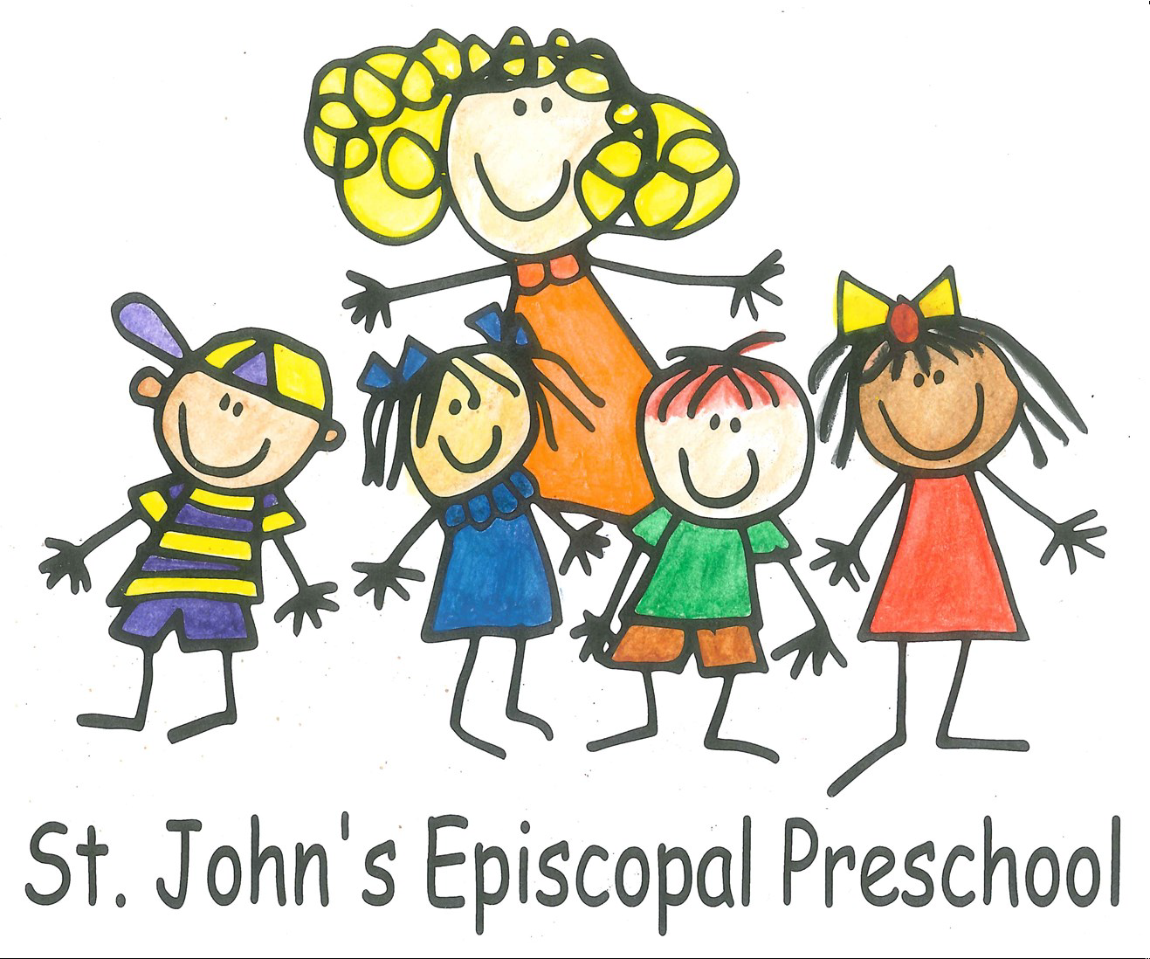

2

TUITION

- TUITION is broken down into 9 payments for the school year and processed through TUITION EXPRESS by the 5th day of the payment month.
Payment Schedule:
Payment #1 MAY of the upcoming school year. #1 is NON-REFUNDABLE
Payment #2 SEPTEMBER
Payment #3 OCTOBER
Payment #4 NOVEMBER
Payment #5 DECEMBER
Payment #6 JANUARY
Payment #7 FEBRUARY
Payment #8 MARCH
Payment #9 APRIL

- The Preschool’s annual budget is based on monthly tuition. Should your plans change during the school year, and your child needs to be withdrawn from the program, St. John’s Preschool requires a thirty (30) days’ notice prior to withdrawal date. If withdrawal is less than 30 days prior to the next payment due, that payment will be processed and not be eligible for refund.

- Any child withdrawn in the months of April or May must pay the balance of the year’s tuition as our preschool is non-profit and depends upon a full year’s tuition commitment.
- REGISTRATION FEE for returning students is due in January for the upcoming school
Year. Registration will then open to the public and classes fill quickly. Class size is subject to
change based on enrollment. The non-refundable registration fee must accompany the
application to be considered registered.

- Students enrolled during the school year will follow payments on a month-to-month schedule.

- An Automatic $25 fee will be charged if the account is NSF.

Please Note:
The Director reserves the right to withdraw a child from the program based on the following:

- If tuition or fees are not paid by a parent.
- If school forms are not signed and turned into the office by the first week of school.
- If a parent or caregiver directs rude or abusive behavior, verbal or nonverbal towards any teacher, staff member, child, or parent of this program.
- If a child develops physical, verbal, or emotional behavior that is categorized as developmentally inappropriate and causes undue stress to teachers or other students in a class.

3
ADDITIONAL FEES

ACTIVITY/RESOURCE FEE - $250 per Child – Due August 15 (prior to the start of school)

The activity fee helps to cover such extra things as:

- Music and Movement with Mrs. Miller
- Music, Library, or Art specials added during the school year
- MY GYM
- Holiday Parties and Special Celebrations

- Chapel Curriculum
- Individual Classroom items: toys, books, manipulatives, etc.
- Classroom supplies to maintain a clean and safe classroom environment.

Additional Fees are non-refundable.



4
HOURS/CARPOOL

- Preschool carpool begins at 9:15 and children are expected to be at school by 9:30.
- Preschool ends at 1:00 PM Monday—Friday. It is very important that your child be picked up promptly. Carpool will begin at 12:50.

LATE PICK-UP POLICY:

Afternoon carpool ends at 1:00. After 1:00 is LATE. You will be charged $3 per minute for arrival after 1:00. Arrival between 1:05-1:10 will incur a $20 late fee charge. Arrival between 1:10-1:15 will incur a $25 late fee charge. You will be billed at the end of the month though Tuition Express.

We will allow a 2-week grace period at the start of school to adjust your schedules and figure out traffic, but after that you will only have 1 free pass, then you will incur the late fee charges. If tardiness becomes habitual, the director may request a meeting. Please understand that our teachers have classroom responsibilities that they must complete before leaving for the day and your tardiness puts them behind schedule.

Please remember to have a carpool buddy that has permission to pick up your child (name and information listed on carpool information sheet) that you can use if you are running late. If you have a true emergency, please contact the office cell phone immediately:

Office Cell 704-998-7221
Office land line 704-366-3039
Parent Connect your teacher

If you are dropping off your child after the morning carpool or picking your child up before 12:50 p.m., please let your teachers and the office know so they can make the necessary arrangements.

If your child is going home with another parent, please send in a handwritten note if possible.

DURING CARPOOL, PLEASE USE THE FOLLOWING GUIDELINES:

In the morning carpool, please have your child remain in the car seat until the teacher opens the car door. DO NOT LET YOUR CHILD HANG OUT OF WINDOWS OR SUNROOF- Safety first.

PLEASE DO NOT BE ON CELL OR CALLS! Teachers will not unload or load your child in car if you are preoccupied by a phone call-it’s a safety issue.
- Make sure you give your child a big “HELLO”-they are excited to see you.
- If the teacher wants to share important info, she will make it brief to not hold up the carpool like, and vice versa please.
- Once your child is in the car, please pull away SLOWLY, PARK, and BUCKLE. Be mindful as you pull away of the other cars.
5

SCHOOL CLOSURE

When CMS (Charlotte Mecklenburg Schools) are closed for weather, SJP is closed.

When CMS has a 2-hour delayed opening, SJP will open on a 1-hour delay (10:15).

- A message will be sent out via Parent Connect regarding closures
- There are NO REFUNDS or MAKE-UP days for any day SJP is closed due to circumstances beyond our control, weather closures, illnesses or scheduled vacation days.
- There are scheduled SJP school closure days designated as teacher workdays to give your child’s teachers time to work on curriculum, prepare for monthly theme changes and attend developmental workshops.

INCLEMENT WEATHER/ SAFETY PROTOCOLS

Inclement weather conditions during school hours will be monitored and if necessary, children will be sent home if conditions continue to deteriorate. It is extremely important that we have up to date phone numbers as well as emergency contacts that can be reached in case of emergency. You will be notified via text or phone call.

Teachers will be kept informed if changing weather conditions indicate that we go into tornado protocol and children will be dismissed only after the treat has passed.

SJP performs fire drills to ensure all children are calm and prepared if a fire emergency arises.

SJP teachers receive CPR and basic first aid training every 2 years and the preschool has an AED located outside the director’s office.

SJP teachers are kept informed of the latest Active Shooter protocols and rooms are equipped with the suggested lock-down door devices.

6

BUILDING SECURITY

In keeping with the philosophy of St. John’s, we feel it is our duty to provide your child with a safe, clean, and secure building. All doors leading into the Preschool section of the building are locked during school hours. All teachers can enter and exit the classroom hallways using a fob, doors lock behind them. If you need to get your child from their class, or you need to take something to them, please use the doorbell on our main entrance door or call the office to let us know you are here.

CONFIDENTIALITY

The following is for any family using or intending to use a SJP staff member for additional childcare outside of preschool hours (afterschool, nights, and weekends):

A Confidentiality Agreement must be signed and returned to the office before a teacher can engage with your family after preschool hours.

Teachers of the preschool may observe or hear information concerning our preschool, fellow staff, and/or students that are sensitive and personal in nature. Please do not ask teachers to share any information regarding the workings of the Preschool, other families and/or students or staff members

7

SJP DISCIPLINE PHILOSOPHY

We believe that a child’s behavior may be unacceptable, but the child is never unacceptable.

Staff work toward the goal of self-control through redirection, unconditional love, and positive re-enforcement. We try not to use the term “time out”. Instead, we encourage the child to take a break from what is causing frustration by choosing another activity that is less stressful for that child and for the group. Violent or destructive expressions of feelings, either physically or verbally, are not acceptable behaviors from a child or a teacher.

The Director does reserve the right to withdraw any child if he or she is continuously disruptive in class due to a physical or emotional problem. Any problem will be discussed with the parents and a course of action will be written out and put into place prior to withdrawal from the program. If after the given time specified for correction, the behavior has not ceased or has gotten worse, the director will move forward on withdrawing the child from the program.

All children who attend St. John’s Preschool are unique individuals with varied needs. Our teachers are committed to diligent observation of children’s development and will notify parents of behaviors and traits that may need to be observed by a professional. If after evaluation by a professional, it is determined that a child’s needs are more complex than our staff and facilities can handle, we will move forward with the following course of action.
- Step 1: Parents will pay to have a shadow hired that will be responsible for assisting their child with day-to-day functions in the classroom.
- Step 2: If there is no change or progress and the child is not benefitting from our program, the child will be asked to withdraw from SJP.

As amazing as our teachers and staff are at SJP, we are not equipped or trained to handle children with exceptional needs.

If the parents of a child with exceptional needs find our program’s expectations are beyond their child’s ability, they may withdraw the student at no penalty.

St. John’s Preschool serves both the church and the community. All children regardless of race, religion, or creed are welcome.

8
HEALTH & WELLNESS

All health forms and documents must be provided by the first week of school. You can access all forms via the preschool website: www.saintjohnspreschool.org/enrollment

If your child has a medical concern that we should know about (allergies, special medication, physical restrictions), as well as any developmental diagnosis, please let us know upon registration. In addition, please make known to your child’s teacher any special needs your child may have.

Your child is very important to us.

  - If a child becomes ill or is injured at school, we will contact you via phone.

  - If we cannot reach you, we will contact the next person listed on your Emergency Locator Form. Your child will be isolated and cared for until you or your emergency contact arrives at the school.

  - If a situation arises in which your child needs hospitalization, we will refer to the hospital listed on emergency form and contact you immediately.

Allergies
- Information regarding substances that your child is allergic to needs to be in writing on the Emergency Locator Form. A copy of your emergency card is kept with the teacher at all times.

Medications
- If your child suffers from a chronic medical condition that requires the administration of medication during the school day, or if your child requires special monitoring (diabetes, food allergies, bee or insect allergies, etc.), please contact the school’s director.

Medical records
- A copy of your child’s current immunization record must be on file at school.

Potty Training

All children entering our 3’s, 4’s or TK classes must be potty trained unless diagnosed with a related issue by a licensed physician.
- Children who are 3-years old at the start of the school year must be potty trained by September 15th. Children who turn 3-years old during the 1st semester (Sept.-Dec) must be potty trained by January 15th. Children who turn 3-years old during the second semester are given 4-6 weeks after their 3rd birthday to be potty trained.
- Children in our young 3’s or 2’s classes beginning potty training must first meet with the child’s teachers to discuss a plan of action before that child is allowed to wear underwear in the classroom. Potty Training depends on teamwork and good communication.

We do not Potty Train in the Toddler Classroom for safety and sanitation purposes.

9

St. John’s Preschool Illness Policies
2025-2026

Cough (persistent):
If your child’s cough is uncontrollable or debilitating, a visit to your pediatrician is highly recommended. Croup or whooping cough can put small children in the hospital if not treated promptly.
Cough due to Asthma:
Please make sure we have a written diagnosis in your child’s medical forms and treatment protocol to ensure we help your child manage their cough when needed.
Covid Positive Diagnosis:
Quarantine for recommended 5 to 7 days with return to school after negative test results. (or current updated CDC guidelines)
Diarrhea:
If your child has explosive or uncontrollable diarrhea at home or at school, they may return to school only after 48 hours diarrhea free and solid stools.
Fever:
A child will be sent home if their temperature is 100.4 or higher and MUST stay home the next day for observation. Children MUST be free of fever (any temperature above 98.6) for at least 24 hours without the use of fever reducing medications before returning to school.
Flu:
Flu is extremely contagious, and the following symptoms may be present: Muscle pain, cough, chills, fatigue, nasal congestion, sneezing, head pressure, headache, shortness of breath or sore throat. Flu can spread amongst family members quickly, quarantine helps prevent the spread of flu and we highly suggest that if you have multiple children at the school and one child is sick, the other should stay home and quarantine as well.
Head Lice:
Treatment must be performed, preferably by professionals (Hair Faries, Lice Clinics, or Pediatric Hair Solutions) and your child’s hair must be completely nit free before they can return to school.

10
Persistent Nasal Discharge:
Deep yellow or green discharge is a sign that your child’s body is working through an infection. If this discharge darkens or is persistently green, antibiotics may be needed to clear up the infection.
Clear discharge could signify the start of a cold or be the result of seasonal allergies. If your child has been diagnosed with seasonal allergies, please give the office a copy of this diagnosis from your pediatrician so that we have it on file.
Rash with itch and/or a fever:
If fever is present, the same rules for fever apply. A visit to your pediatrician is highly recommended to prevent the spread of contagious infections like Impetigo, Hand-Foot-Mouth, Ringworm, Chicken Pox, and Fifth Disease. Topical medication may be required to clear rash.
Red, weepy, crusty, or swollen eyes:
Eyes must be evaluated by a physician to provide proof that the cause of redness is NOT Conjunctivitis (pink eye). If it is Conjunctivitis, this is a VERY contagious infection. Child may return to school after a course of antibiotics for a minimum of 24 hours and a doctor’s note.
Sore Throat:
Return to school after 24 hours of antibiotic treatment and a doctor’s note.
Vomiting:
If your child vomits at home, in the car to school, or at school, they may not return to school for 48 hours and MUST be vomit free for at least 2 solid meals.

The purpose of these policies is to ensure that St. John’s Preschool maintains a healthy classroom environment for all of our students and teachers. Health and Medical concerns from your child’s teachers will be brought to the office’s immediate attention. If administration has a question or concern about your child’s health, we will notify a parent(s) immediately via text or phone call. If a parent does not reply or respond, we will begin to call the emergency contacts you have provided to come and pick up your child to address our health concerns.

Teachers are an important part of helping to maintain the health and well-being of our students. Please make sure they are aware of any health or developmental issues that your child may have. If you have any questions regarding these policies, please direct them to the director. Thank you.
11

St. John’s Preschool Policies and Procedures Acknowledgement Form
TUITION:
- Tuition is 9 payments processed using TUITION EXPRESS for the school year.
- Payment #1 is processed in May of the upcoming school year and is NON-REFUNDABLE once processed.
- Payment #2 is processed September, Payment #3 is processed October, Payment #4 is processed November, Payment #5 is processed December, Payment #6 is processed January, Payment #7 is processed February, Payment #8 is processed March, Payment #9 is processed April of the school year.
- Withdrawal of any child from the program requires 30-day advance notice before the next tuition payment. If the withdrawal is less than 30 days, you are responsible for the next tuition payment.
- Any child withdrawn in the months of April or May must pay the balance of the year’s tuition as our preschool is non-profit and depends upon a full year’s tuition commitment.
- Registration and Activity Fees are NON-REFUNDABLE.
- An Automatic $25 will be charged if the account linked to Tuition Express comes back NSF. All account holders are responsible for updated checking account information.

I understand the above tuition policies ______________ ______________
(parent 1 initial) (parent 2 initial)
CARPOOL :
- Morning Carpool begins at 9:15 (children should be in school by 9:30)
- Afternoon Carpool begins at 12:50 and ends at 1:00.
- After 1:00 is LATE.
- You will be charged $3 per minute for arrival after 1:00.
- Arrival between 1:05-1:10 will incur a $20 late fee charge.
- Arrival between 1:10-1:15 will incur a $25 late fee charge. You will be billed at the end of the month though Tuition Express.
- There will be a 2-week grace period at the start of school to adjust your schedules and figure out traffic, but after that you will only have 1 free pass, then you will incur the late fee charges.
- **REMINDER** Have a carpool buddy on file who can pick up your child if you are running late or caught in traffic.
- Please refrain from using cell phones (handheld or through vehicle Bluetooth) during carpool. Your focus should be on your child and other cars on the carpool line.
- FOR SAFETY!!! Please DO NOT Allow your child to hang out car windows, sunroofs, or sit in your lap during carpool.

I understand the above carpool policies_______________ ________________
(parent 1 initial) (parent 2 initial)
SCHOOL CLOSURE:
When CMS (Charlotte Mecklenburg Schools) are closed, SJP is closed.
When CMS has a 2-hour delayed opening, SJP will open on a 1-hour delay (carpool begins at 10:15).
- A message will be sent out via Parent Connect regarding closures
- There are NO REFUNDS or MAKE-UP days for any day SJP is closed due to circumstances beyond our control, weather closures, illnesses or scheduled vacation days.
- There are scheduled SJP school closure days designated as teacher workdays to give your child’s teachers time to work on curriculum, prepare for monthly theme changes and attend developmental workshops.

I understand the above school closure policies ____________ ____________
(parent 1 initial) (parent 2 initial)

HEALTH:
- Diarrhea: If your child has explosive or uncontrollable diarrhea at home or at school, they may return to school only after 48 hours diarrhea free and solid stools.
- Fever: A child will be sent home if their temperature is 100.4 or higher and MUST stay home the next day for observation. Children MUST be free of fever (any temperature above 98.6) for at least 24 hours without the use of fever reducing medications before returning to school.
- Vomiting: If your child vomits at home, in the car to school, or at school, they may not return to school for 48 hours and MUST be vomit free for at least 2 solid meals.

I understand the above health policies __________________ ________________
(parent 1 initial) (parent 2 initial)

*Please note-These are the 3 most common reasons a child is sent home from SJP. Please refer to the Health Section in the Parent handbook for a more extensive list of our health policies.

POTTY -TRAINING: (for parents of children in our Older 2’s and 3’s program)
- Children who are 3-years old at the start of the school year must be potty trained by September 15th.
- Children who turn 3-years old during the 1st semester (Sept.-Dec) must be potty trained by January 15th.
- Children who turn 3-years old during the second semester are given 4-6 weeks after their birthday to be potty trained.
- If you are struggling with potty training, please discuss it with your child’s teacher. If necessary, a plan of action will be created for your child to remain at school during this process. In some situations, a child may be asked to stay home until training is completed.
I understand the above potty-training policies:______________ _________________
(parent 1 initial) (parent 2 initial)

We have read, acknowledged, understand, and accepted these policies as well as the policies and procedures in the 2025-2026 St. John’s Preschool handbook.
St. John’s Preschool reserves the right to update/change certain criteria as needed.
St. John’s Preschool reserves the right to withdraw a student for non-payment of any fee.
Please sign and return prior to or on first day of school. Both Parents or Responsible Parties must sign and return to administration office before a child can attend St. John’s Preschool.

Sign____________________________________________ Date___________________

Sign____________________________________________ Date___________________

